**Payroll System Case**

**Case Overview**

This case is created to manage the payroll of Locks A2Z, Inc which works for customers to meet their locks and security needs. This case in designed to maintain time card, maintaining purchase order, maintaining employee information ,selecting payment method, generating employee report and generating administrative reports and generating paychecks to the employee.

Here, I have covered the user/actor identification, requirement identification and gathering techniques. Also, I have prepared the BRD and FRD templates with use case diagram.

**User Identification**

The payroll system is build to retain the information of all employees in the company. The system must pay each employee the correct amount, on time, by the method that they specify.

Some employees work by the hour, and they are paid an hourly rate. They submit timecards that record the date and number of hours worked for a particular charge number. If someone works for more than 8 hours, A2Z pays them 1.5 times their normal rate for those extra hours. Some employees are paid a flat salary. Even though they are paid a flat salary, they submit timecards that record the date and hours worked. This is so the system can keep track of the hours worked against particular charge numbers. Some of the salaried employees also receive a commission based on their sales.

Also, One of the most important feature of this system is " Employee Reporting". Where employee will able to track his/her number of hours worked, totals of all hours billed to a project, total pay received year-to-date, remaining vacation time, etc.

Employees can choose their method of payment. They can have their paychecks mailed to the postal address of their choice, or they can request direct deposit and have their paycheck deposited into a bank account of their choosing. The employee may also choose to pick their paychecks up at the office.

The Payroll Administrator maintains employee information. The Payroll Administrator is responsible for adding new employees, deleting employees and changing all employee information such as name, address, and payment classification (hourly, salaried, commissioned), as well as running administrative reports.

The payroll application will run automatically on stated time and date. It will pay the appropriate employees on those days. The system will be told what date the employees are to be paid, so it will generate payments for records from the last time the employee was paid to the specified date. The new system is being designed so that the payroll will always be generated automatically, and there will be no need for any manual intervention.

**Actors:**

1.Permanent employee

2. Database (PMDB)

3. Clock

4. Payroll Administrator

5. Hourly Employee

6. Contract Employee

7. Salaried Commissioned employee

8. Bank

**Use Case:**

1. Entering time card information 2. Enter purchase order

3. Change employee pay preferences

4. Generate employee query report 5. Maintain employee info

6. Generate Paycheck 7. Select method of payment

8. Generate administrative reports 9. Login

**Requirement Gathering Techniques**

1. Distributing **Questionnaire** to employees (they are many ) to know their contact information, preferred payment method, work hour preference and so on.

2. Conducting **JAD** meeting with department heads of finance, HR and payroll administrator. Payroll administrator maintains the overall payroll system, HR hires and fires the employees and accounting department is responsible to issue the payment. So, JAD will be effective to make quick decision.

**BRD and FRD template**

|  |  |  |  |
| --- | --- | --- | --- |
| BR | Module | Entity Involved | Description |
|  |  |  |  |
| B1 | Login & Logout | Employee | Employee login |
| B2 | Working Hours | Employee | Attendance |

FRD for Employee:

Requirement Code:

B1

* TR1----Employee Id must not be blank
* TR2----Password must not be blank

B2

* TR1----Marking start time for the day
* TR2----Marking leaving time with total hours worked

Payroll Administrator

|  |  |  |  |
| --- | --- | --- | --- |
| BR | Module | Entity Involved | Description |
|  |  |  |  |
| B1 | Login & Logout | Payroll Admin | Employee login details |
| B2 | Attendance report | Payroll Admin | Overall report view |

FRD for Payroll Admin:

Requirement Code:

B1

* TR1----Employee Id must not be blank
* TR2----Password must not be Blank
* TR3---- Password must be minimum 8 digits with number

B2

* TR1----Attendance Report of overall employees
* TR2----Total Work hour report of overall employees

**Scenarios:**

**Use case: Maintain Time card information:**

If he is able to do this successfully, then its normal flows. If not, its alternate flow.

1. Use Case Name: **Maintain Timecard**
2. Use case Brief Description

This use case allows all categories of employees to update the time card information

1. Flow of Events:

The Use case starts when employee wishes to create/edit/update/view his time card.

Employee if he wishes to create the time card then the following sub flow is performed:

* 1. Employee request the system to create time card by clicking time create card button.
  2. System will present the following information to the employee.
* Employee id (integers and the system will fetch the same if the employee is logged in)
* Employee name (Alphabets ….)
* Category of Employee ( …)
  1. System will ask the employee if the information is correct and wants to proceed further i.e. Continue
  2. Employee selects YES/NO/Cancel.
  3. If YES, the system will present the following information to the employee.
* Time card Id (auto generated)
* Start Time (date and time format)
* End time (date and time format)
* Total number of hours worked ( date and time format)
  1. Employee fills the above. System validates and saves the information. Time card is created.
  2. Use case ends here.

If the employee selects Edit/ Edit-save

The following sub flow is performed.

Alternate Flow

3.4.1 If Employee selects NO, the process ends there.

3.4.2 If the Employee selects Cancel, it should go to the previous state.

3.5.1 Please select the correct date and time format.

**Use Case: Maintain Purchase Order**

1. Use case Name: **Maintain** **purchase order**

2. Use case Brief Description: This use case allows the payroll administrator to maintain the purchase order and set commission for the salesman.

1. Flow of Events:

The Use case starts when the payroll administrator wishes to enter the purchase order.

* 1. Employee ( salesman) submit their purchase order to the payroll administrator. The purchase order contains the following information:
* Employee (salesman Name)
* Sales id
* Sales date
* Amount of sale
  1. The payroll administrator selects the enter purchase order tab and enters the above information on the respective fields.
  2. The payroll administrator selects the commission percentage based on the type of employee or the system can also select the commission automatically based on the type of employee or the amount of sales.
  3. The payroll administrator submits the purchase order to the system
  4. The system prompts for the confirmation with “ Submit Purchase order?” with yes/No or cancels options
  5. If the payroll administrator selects the “Yes” option , the purchase order is submitted to the system and the system asks whether he wants to create an new order again with yes/no option. If he selects yes, the same procedure is repeated from 3.1 to 3.5. if he selects no Use case ends here and goes to the main menu.

Alternate Flow:

* + 1. if he selects the “ No” option , it stays on the current state so that he can edit the purchase order or return to main menu or cancel the purchase order.
    2. If he selects the cancel button the purchase order procedure is cancelled and he returns to the main menu and the use case ends here.

**Use Case : Select Payment Method**

Select payment by bank/ by post office/by self pickup

If he is able to do this successfully, then its normal flows. If not, its alternate flow.

1. Use case name: **Select payment Method**
2. Use Case brief Description:

This use case allows the employee to select their method of payment. This can be on a separate page or can be set up or edited while creating/editing a user profile.

1. Flow of Events:

The use case starts when the employee logs in and chooses to select the method of payment option.

* 1. The employee selects the choose method of payment option
  2. This provides him with the various payment option such as mail to postal address, direct deposit or pick up.
  3. The employee selects one of the options and selects to submit the information.
  4. The system prompts him with the confirmation message with yes/ no/cancel.
  5. If the employee selects yes option the system is updated with the employee payment method.

Alternate flow:

* + 1. if the employee selects No option, it stays on the current page so that he can edit and resubmit, process from 3.3 is repeated.
    2. If the employee selects cancel option the process is cancelled and returns to the main page

**Use Case: Generate Employee query report**

Query the system for no of hrs worked/ total no of hrs went to the project/ total pay recd

If he is able to do this successfully, then its normal flows. If not, its alternate flow.

1. Use Case Name: **Generate Employee Query report**
2. Use Case Brief description: This use case allows the employs to view their personal information such as number of hours worked, total of all hours billed to a project, total pay received year –to- date, remaining vacation time etc.
3. Flow of events:
   1. The employee logs in and selects the generate employee query report option
   2. The system displays all the information like total number of hours worked, total of all hours billed to a project, total pay received year to date, remaining vacations, current project that the employee is working on etc and all the relevant information about that employee.

Alternate flow:

* + 1. If the employee is a recently added employee, then the system displays “No records found” information and returns to the main menu.

**Use case: Maintain employee info**

Adding new employees/ Deleting employee/Promotion/ Demotion

If he is able to do this successfully, then its normal flows. If not, its alternate flow.

1. Use case Name: **Maintain Employee Info**
2. Use Case Brief Description: This use case allows the payroll administrator to add, delete and change employee information such as name address and payment classification.
3. Flow of events:
   1. The payroll administrator selects appropriate options whether he wants to add an employee, delete an employee, and update an employee or running an administrative report.
   2. If the administrator selects an add an employee option, he is provided with the employee add page where he can add and employee by adding all his personal information like his ID, Address and all other relevant information , the system has asked for.
      1. After the employee is added the administrator submits the add employee button.
      2. The administrator is prompted with the confirmation message with yes/No or cancel
      3. If the administrator selects the YES option then the employee is successfully added to the system. He is prompted by the add another employee option. If he selects yes, steps from 3.2.1 is repeated, if he selects NO then it return to the main menu.

Alternate Flow:

* + 1. If the administrator selects the NO option then it stays on the current page so that he can edit the information and submit again, steps from 3.2.1. is repeated.
    2. If the administrator selects the cancel option, the procedure is cancelled and it returns to the main menu.
  1. If the administrator selects the “ delete an employee option”, he is asked to enter the employee Id and name
     1. if the employee Id and name matches , all the basic employee information is displayed so that he can delete the employee
     2. When he deletes the employee, he is prompted with the confirmation message with YES/ NO or cancel options
     3. If he selects the YES option then he is given a confirmation message that the employee is successfully deleted.

Alternate Flow:

* + 1. If he selects the No option then it stays on the current page so that he can edit the information.
    2. If he selects the cancel button, then it returns to the main menu
  1. If the administrator selects to update an employee then he is asked to enter the employee id and employee name to be updated
     1. The system provides all the information about the employee where the administrator updates all the information that needs to be changed and submits the information.
     2. The system prompts with the confirmation message YES/ NO or Cancel
     3. If he selects the YES option then the system is updated with the new information of the employee and it return to the main menu.

Alternate Flow:

* + 1. If he selects the NO option then it stays on the current page
    2. If he selects the cancel option then it returns on the main menu.
  1. If the administrator selects the run administrative report option then, he is prompted with a option of selecting whether to sun an individual employee report or the overall report.
     1. If he selects to run an individual employee report, then he is asked to enter the employee id and employee name, If the employee id and name matches the all the information about the employee is displayed.

Alternate Flow

* + - 1. If the employee id and name does not matches then it displays the “No record found” message.
    1. If he chooses to run the overall report then all the basic information about the entire employee is displayed.

Alternate Flow

* + 1. He can return to the main menu by selecting return to the main menu option.

**Use Case :Generate administration reports**

Generate admin report successfully

If he is able to do this successfully, then its normal flows. If not, its alternate flow.

1. Use case Name: **Generate Administration report**
2. Brief Description:

This Use case generates the administrative reports and it can only be generated by the payroll administrator.

1. The payroll administrator selects generate administrative reports tab.
   1. The system allows the administrator to choose a date range.
   2. If the date range is valid then the all the reports about all the employees is displayed

Alternate Flow:

* 1. If the date range is invalid, he is given an error message so that he can either stay on the current page or return to main menu.

**Use Case: Generate paychecks**

If he is able to do this successfully, then its normal flows. If not, its alternate

1. Use case name: **Generate Paychecks**
2. Use case brief Description

This use case generates the paychecks for the employee. This runs automatically on every Friday and on the last working day of the month.

1. Flow of events: the system automatically detects the day of the month according to the system’s date and time. If it is either Friday or the last working day of the Month then the system runs the generate paycheck use case.
   1. The system is set up to what date the employees are to be paid, so it will automatically generate the paycheck for that employee on that date.
   2. It will generate the record for the payment from the last time to the specified date.

**Use case for Payroll System**

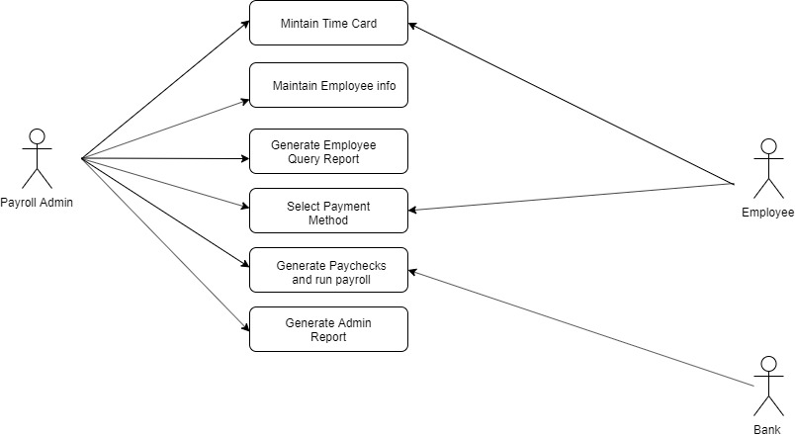

**Activity Diagram**

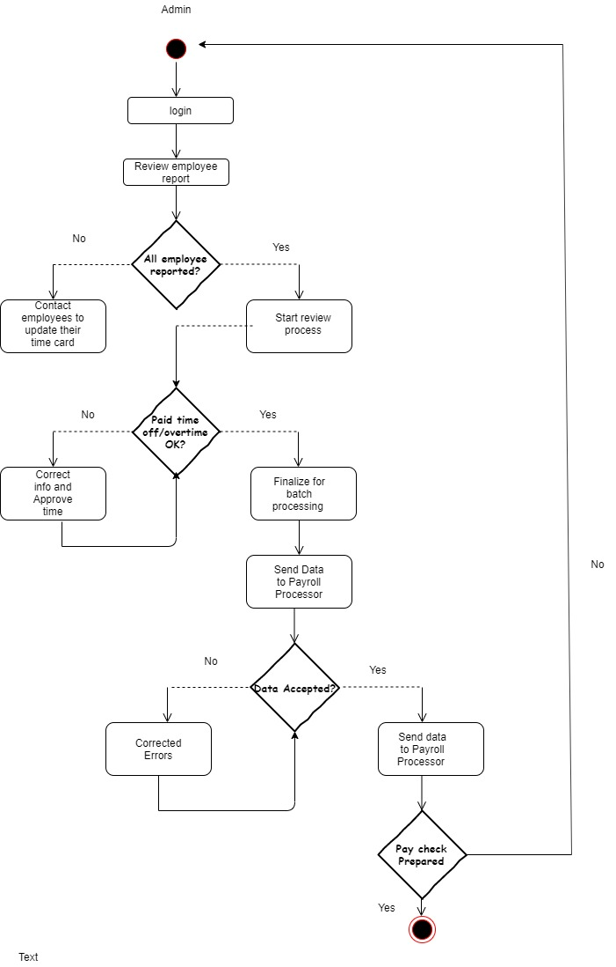

**TestCase Template**

|  |  |  |  |  |  |  |  |
| --- | --- | --- | --- | --- | --- | --- | --- |
| Test Case ID | BR | TR | Test Case Description | Test Data | Expectation | Author | Result |
| TC1 | B1 | TR1 | Check Login functionality | abc@123,qrs@123 | Pass | Tester A |  |
| TC2 | B2 | TR2 | Check the search functionality |  | Pass | Tester A |  |
| TC3 | B3 | TR3 | Check the employee timecard page |  | Pass | Tester A |  |
| TC4 | B4 | TR4 | Check Payment functionality |  | Pass | Tester A |  |
| TC5 | B5 | TR5 | Check the payment order |  | Pass | Tester A |  |